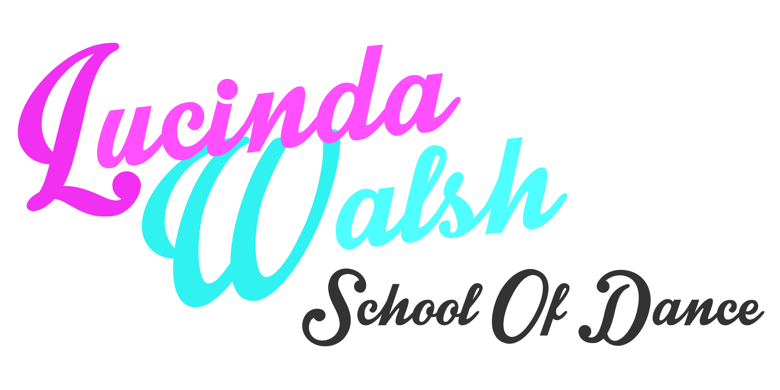

SAFEGUARDING POLICY

Lucinda Walsh School of Dance will:

1. Provide efficient, up-to-date, enjoyable and safe instruction in dance to all pupils who enrol in the school or join in the classes or activities.
2. Ensure the premises and equipment are checked regularly for any defects or faults that exist or may have developed which might present hazards to any attending the premises.
3. Make sure the premises will be cleaned regularly to prevent any hazard to health from accumulated dirt or rubbish.
4. Ensure all instruction will be geared to the previous experience and abilities of the pupil(s) and no person will be required to perform movements beyond their intrinsic capabilities. Staff will be sensitive to all pupils’ religious beliefs and culture.
5. No energetic instruction will be given without pupils undergoing a “warm-up” session, and after an energetic session completing a “warm-down” session.
6. A day book will be kept to allow records to be kept of any incident in the school, injuries of any nature to staff or pupils.
7. Very young pupils will not be allowed to leave the school premises until collected by a parent, guardian or other adult authorised to do so by a parent or guardian. A member of staff will remain on the premises until all pupils have left. Older student will only be allowed to leave the premises if they have permission signed by their responsible adult and the Dance School deem them mature and responsible enough to do so.
8. Pupils under age 16 will not be driven home by a member of staff in his/her car without the permission of a parent or guardian or in the event of an emergency.
9. Members of staff will not be alone with a young pupil for any substantial period of time without the consent of a parent or other authorised person.
10. If appropriate, changing facilities will be provided. Where possible parents should supervise their own children in the changing area otherwise supervision will not be by a single adult.
11. Children will not be photographed or videoed without the consent of parent or guardian.
12. Disclosure and Barring Service (DBS) checks to be made.
13. Only suitably qualified persons will be employed in a teaching capacity while any student engaged to assist with teaching will only work under the supervision of a qualified member of staff.
14. In the event of activities outside the school premises the instructors will regard themselves as being in “loco parentis” and, so far as applicable and within their control, apply the preceding and subsequent guide lines as if the event was in their own studio.
15. Teachers will avoid any unnecessary physical contact with pupils. However parents should understand that some aspects of teaching involve some contact. Where it is necessary teachers will use the utmost discretion and, in any event, not do so without another adult in the room.
16. The school principal (Lucinda Walsh) will ensure that she and the members of staff are properly covered against incidents involving public liability and professional negligence insurance.
17. The school principal (Lucinda Walsh) undertake not to involve in misleading or false advertising.
18. Discrimination by means of religion, race, children’s background or any other accepted discrimination classification will not be tolerated by the school.
19. At all times, all staff will endeavour to keep the highest standards of instruction and behaviour. The school principal (Lucinda Walsh) retains the right to discharge from the school any pupil who persistently disrupts the tuition, uses offensive language, or other anti-social behaviour.

Date of review: 20/08/18
Reviewed by: Lucinda Walsh

This policy will be regularly monitored by the Executive Committee of the organisation and will be subject to annual review.

Date: August 2019.

